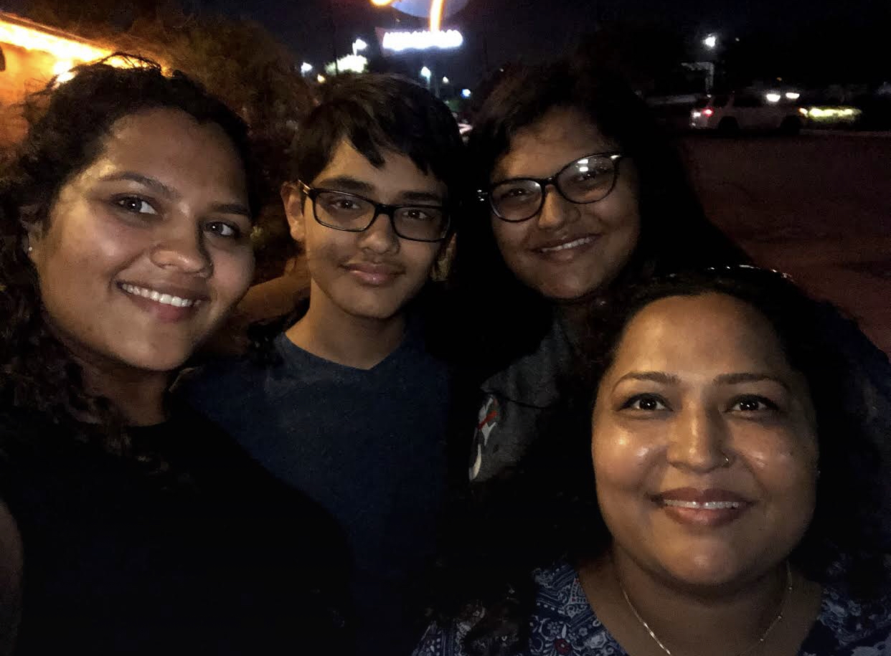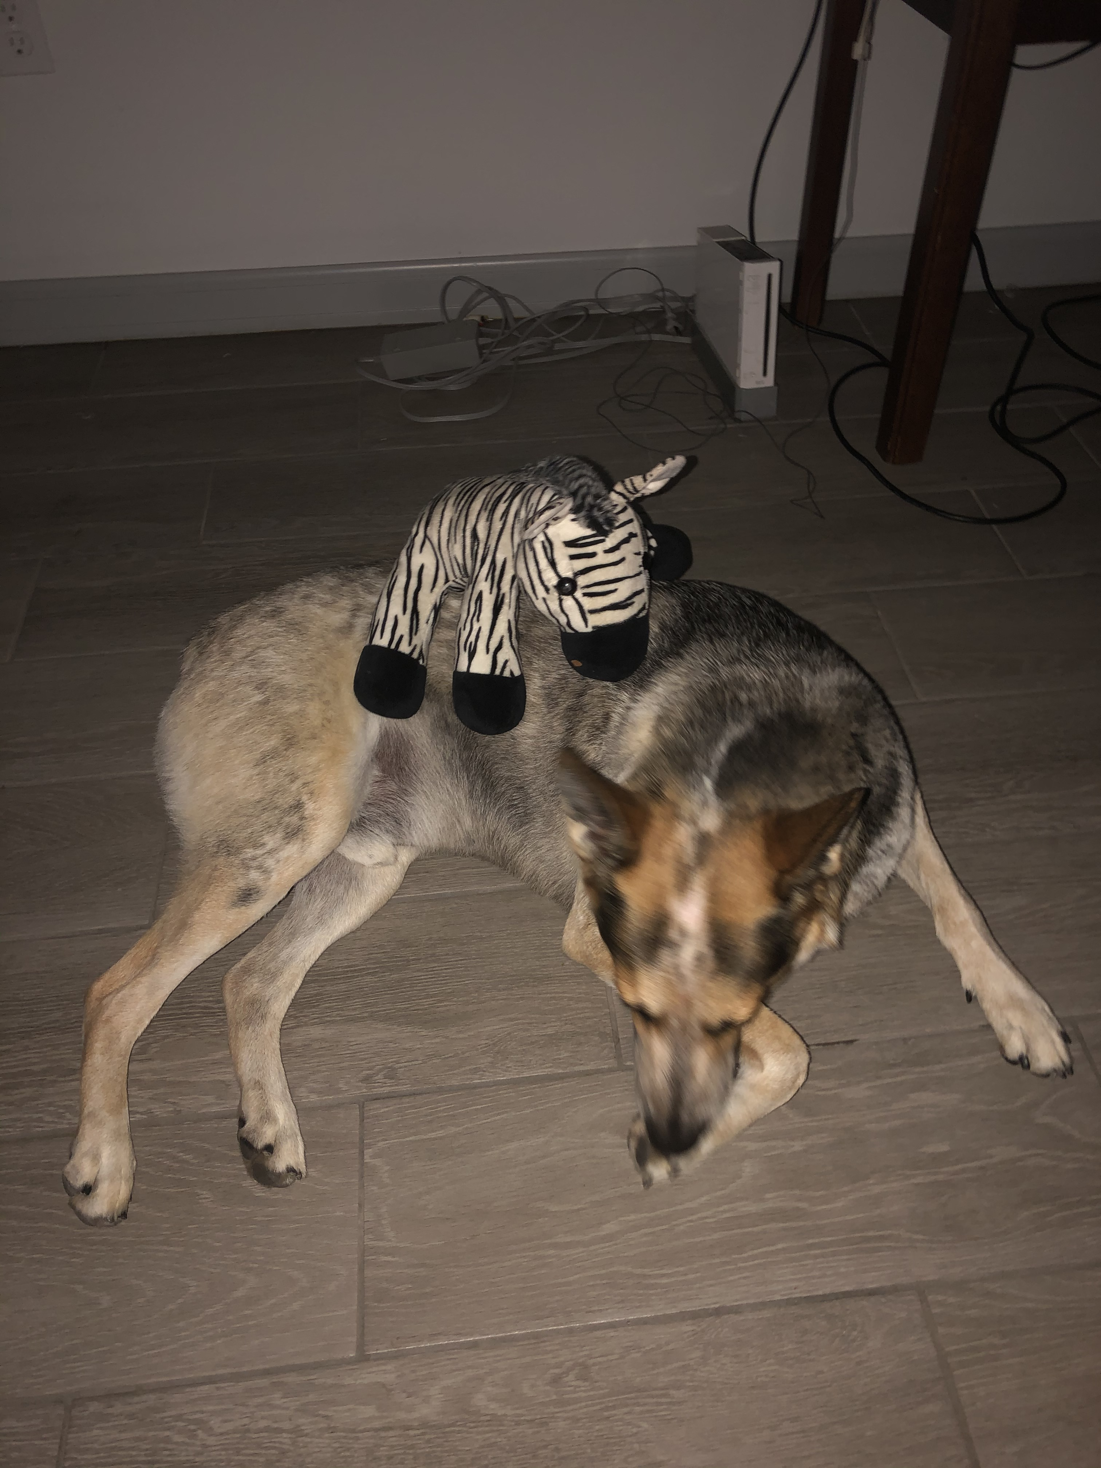

This new learning style is hard to get used to, just sitting in my room staring at a screen all day, just trying to get through school no matter how boring class can get. Its hard for me to be home because of my dog who always wants to play or go outside, me wanting to play basketball or wanting to play video games, or that fact that I live I live in a motel so I go to the customers to rent rooms and its always at random times so when they come during a class then I have to go. My sister will also go at some points in time but for the most part it’s just me. And to add on to the extra things around the house, my mom is on bed rest because she had a surgery on Tuesday. She had the surgery to get tumor removed and, in the process, they removed her uterus, so she is unable to help around the house for some time so she can heal, and because of all of this, some of my goals ae going to be hard to achieve. My most major goal, as of right now, is to get through online school and keep my grades up instead of having them drop to low to a failing grade. I do not really have any other plans to accomplish any time soon for time being so hopefully I don’t get to bombarded by things I need to do anytime soon. I expect for this course to have an average difficulty but many challenges for me to get through so I can learn many new things and have fun at the same time. This class was one of my favorite classes last year because of the group assignments we got to do about the book and all the minor assignments that were super easy were actually pretty fun to do. With the transition to online learning though I really hope we don’t lose these aspects of the class because not being face to face with your teacher at all times during a class just feels different and free in a sense. I have to admit I do go on my phone ever now and then a during class, mainly during the end during the free time, because its feels more boing and free compared to a regular face to face classroom that’s isn’t as boring and you keep your attention on the assignment at hand. Its even more difficult cause I don’t have a private desk to sit on and go to zoom. I have to sit on my bed and I almost always have the temptation to just go to sleep at most times during classes. Online classes can be very difficult to get used to and work around but hopefully I can work past the challenges I face during this time so I can get through this school year, pass my classes and have fun in my zoom class with my peers.

